Name: _____________________ Class:__________ Date:__________
Instructions: Write answers in the right-hand column. Score: ___________ / 45 marks
Section A— Multiple choice (10 marks)

 | Energy is measured using a unit called the:  A kilogram.  B metre.  C second.  D joule. | D | 1
 | Select which of the following require energy to happen.  A running in a race  B a leaf falling from a tree  C clothes drying in the sun  D all of the above | D | 1
 | The energy of a moving object is called:  A nuclear energy.  B gravitational potential energy.  C elastic potential energy.  D kinetic energy. | D | 1
 | Jordan watches a music video clip on his iPhone. Choose the best description of the energy transformations that are happening.  A electrical energy → sound energy + light energy + heat energy  B electrical energy → sound energy + light energy  C sound energy + light energy + heat energy → electrical energy  D sound energy + light energy → electrical energy | A | 1
 | A particular electric knife is 40% efficient. If 100 J of energy is supplied to the knife, the number of joules that is then transformed into kinetic energy is:  A 40  B 100  C 60  D 140 | a | 1
 | The number of stars found on an Energy Rating Label indicate:  A the energy efficiency of an appliance.  B how much energy the appliance will require to operate.  C how much effort needs to be taken to maintain the appliance.  D how easy the appliance is to clean. | A | 1
 | Select which of the following contains elastic potential energy.  A a stretched bow about to fire an arrow  B a tree branch  C a seagull in flight  D an apple | A | 1
 | Select which device transforms chemical energy into kinetic energy.  A a torch  B a battery operated car  C a kettle  D an electric knife | B | 1
 | Heat flows from areas of:  A higher temperature to those of lower temperature.  B the same temperature.  C lower temperature to those of higher temperature.  D all of the above. | A | 1
 | Select the correct energy flow diagram showing energy changes that occur when operating a battery-operated fire truck that moves and sounds a siren.  A electrical energy → chemical energy + sound energy  B chemical energy → sound + heat energy  C electrical energy → heat + elastic potential energy  D chemical energy → kinetic energy + sound + heat | D | 1

Section B— Short answer (25 marks)

- ` | List three types of energy that are present when a match is lit. | Any three of kinetic, heat, sound, chemical, light | 1
 | A red Honda travels at 20 km/h around a curved road near the top of a mountain. A blue Honda travels at 50 km/h along a flat road near a beach.  a State which car has the greatest kinetic energy.  b State which car has the greatest gravitational potential energy.  c Explain your answers above. | a the blue car  b the red car  c the red car has the greater gravitational potential energy because it is moving on an elevated mountain road, and is at a greater height than the blue car, which is close to sea level.  The blue car has the greater amount of kinetic energy because it is travelling at a higher speed than the red car. | 3
 | Explain the difference between an energy transfer and an energy transformation. | An energy transfer occurs when energy is passed from one object to another. For example, the kinetic energy of your foot is transferred to a ball as it is kicked.  An energy transformation refers to one form of energy changing into another form of energy. For example, electrical energy is transformed into light and heat energy when a light globe is turned on. | 2
 | James watches a television show after school.  a State the source of energy for the television.  b List any forms of energy that this energy is transformed into. | a electrical energy  b heat energy, sound energy, light energy | 2
 | a State whether a television can be 100% efficient.  b Explain your response. | a no  b All devices produce some heat. Because this heat is not required for the viewing of the television, it is unwanted energy. This means that some electrical energy is wasted to produce this heat, making the television less than 100% efficient. | 2
 | Sienna turns around in a shop and her handbag knocks a vase from a stand. The vase falls and smashes on the floor.  a Recall the initial type of energy possessed by the vase.  b State the name of the type of energy that this is transformed into as the vase falls.  c Identify one other form of energy that is also transformed in this situation. | a gravitational potential energy  b kinetic energy  c Some of the initial energy is also transformed into heat and sound energy as the vase falls and smashes on the floor. | 3
 | 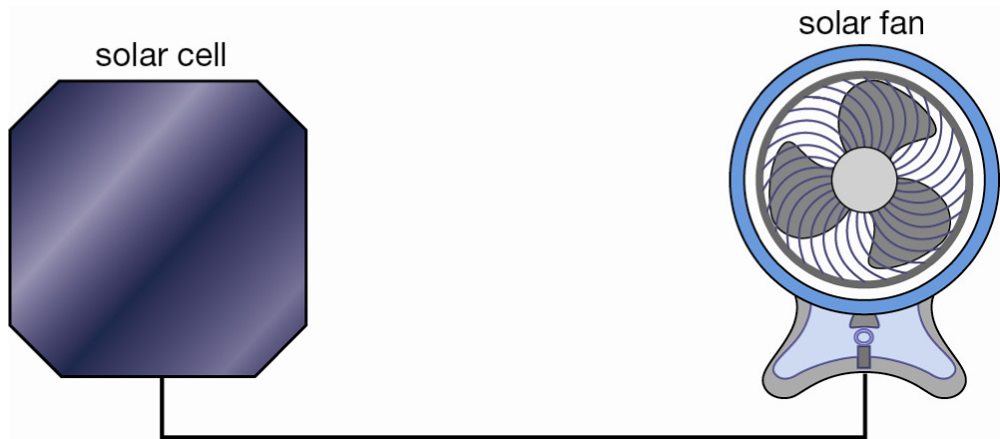  This diagram shows a solar cell that is used to operate a solar fan.  Draw an energy flow diagram to show the energy changes that take place in this process. | Light energy → electrical energy → kinetic energy + sound energy + heat energy | 3
 | Consider the four situations listed below.  a a solar fan starts to spin  b Abdul dives into a pool  c newspaper burns in a fire  d a battery operated mouse rolls along the floor  Use your knowledge of energy transformation to match each situation listed above with the correct energy transformation, A, B, C or D.  A gravitational potential energy → kinetic energy + sound energy + heat energy  B light energy → kinetic energy + sound energy + heat energy  C chemical energy → light energy + sound energy + heat energy  D chemical energy → kinetic energy + sound energy + heat energy | a B  b A  c C  d D | 4
 | Use the diagram below to construct an energy flow diagram showing the energy changes that occur when using a microwave oven if your energy supply is wind powered.  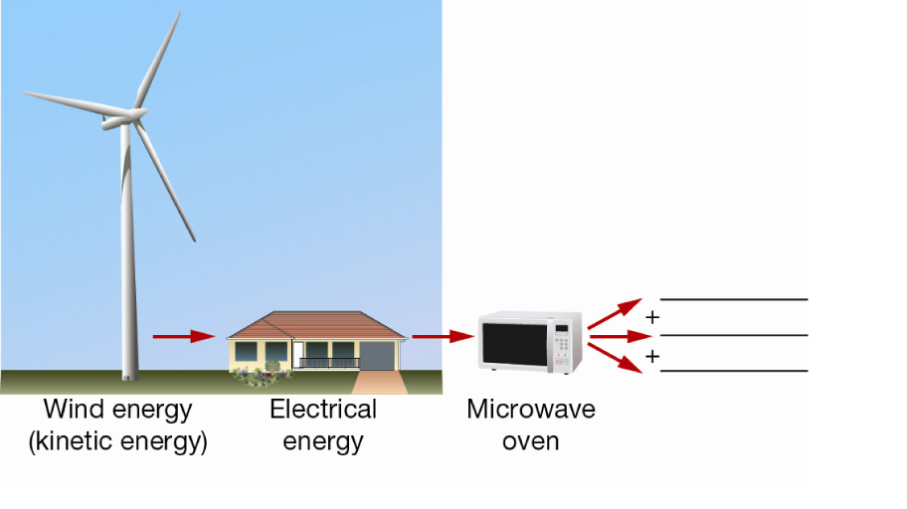 | kinetic energy → electrical energy → kinetic energy + sound + heat energy | 3
 | a List one useful forms of energy that are produced when you use an electric drill.  b Identify two other forms of energy that are produced that are not useful. | a kinetic energy of the rotating drill bit  b heat and sound energy | 2

Section C— Thinking scientifically (10 marks)

 | 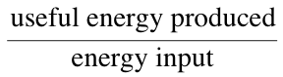  The efficiency of an appliance is the ratio of:  If a food processor is 25% efficient, then for every 10 kJ input, its useful energy output is:  A 25 kJ  B 75 kJ  C 2.5 kJ  D 7.5 kJ | C | 1
 | If the efficiency of the Spinners washing machine is 40%, Sparkles washing machine is 35% and the Sprinkles washing machine is 52%, then the machines listed from most to least efficient are:  A Spinners, Sparkles, Sprinkles  B Sparkles, Sprinkles, Spinners  C Sprinkles, Spinners, Sparkles  D Sparkles, Spinners, Sprinkles | C | 1
 | The table below lists the specific thermal capabilities of a number of materials. This unit is the number of joules of energy that is needed to raise the temperature of 1 kg of this substance by 1° Celsius.  If each material listed in the table was heated with 100 kJ of energy, the material that would be the hottest after heating is:  A water  B oil  C glass  D copper | D | 1
  Substance | Specific thermal capacity (J/kg/°C)
  water | 4180
  oil | 2800
  glass | 840
  copper | 385
 | The table below lists the thermal conductivities of a number of materials. This unit is a measure of how well a material conducts heat. The larger the thermal conductivity, the better the material will conduct heat.  If a sample of each of these materials is placed outside on a sunny day, select the alternative that lists how they would feel to touch, in order from hottest to coolest:  A glass, steel, cork, wood, copper  B copper, steel, glass, cork, wood  C steel, copper, glass, cork, wood  D wood, cork, glass, steel, copper | B | 1
  Substance | Thermal conductivity  (W/m °C)
  glass | 0.84
  steel | 40
  cork | 0.42
  wood | 0.10
  copper | 380
 | The table below lists the typical amount of energy required per minute by a  58kg woman and a 70kg man to perform several activities.  Lisa weighs 58 kg. In one particular hour, she uses up 720 kJ of energy. Select the activity that she was most likely to be involved in.  A lying on the couch watching television  B working in a chemist  C riding her bike  D playing football | B | 1
  Activity | Average energy required per minute by a 58kg woman | Average energy required per minute by a 70kg man
  Sleeping or resting | 4 | 5
  Working on a computer | 8 | 10
  Light work: shop keeping, gardening | 12 | 16
  Social sports such as cycling, playing tennis or cricket | 16 | 20
  Heavy work: chopping wood, running, competitive sports | 24 | 30
  Intense exercise such as hard physical work | 40+ | 50+
 | Josh weighs 70kg. In one particular hour, he uses up 1800 kJ of energy. Referring to the table shown in the previous question, the activity that he was most likely to be involved in is:  A lying on the couch watching television  B working in a chemist  C riding his bike  D playing football | D | 1
 | Alice is playing in a netball tournament. If she burns up about 20 kJ per minute playing netball, estimate how long she would need to play to work off the energy of the 800 kJ Powertonic sports drink she drinks before the tournament starts.  A 10 minutes  B 20 minutes  C 30 minutes  D 40 minutes | D | 1
 | The higher the star rating of an appliance, the more energy efficient the appliance is. Three similarly-sized clothes dryers: X, Y and Z are tested to assess their star rating. Clothes dryer X wastes 60% of the energy put into it. Clothes Dryer Y is 20% efficient. Clothes dryer Z wastes 35% of the energy input. The three clothes dryers listed in increasing order of the number of stars that appear on the label are:  A X, Y and Z  B Z, Y and X  C Y, X and Z  D Y, Z and X | C | 1
 | Whenever an object is shifted or changes shape, work has been done. Select the situation below in which work has been done on an object:  A a cat sits on a rug  B Ben lifts his dog’s food dish  C sunlight shines on a parked car  D music plays from a radio | B | 1
 | An effective insulator traps heat. The effectiveness of three brands of thermos are shown below. An equal volume of water at 80° C was poured into each thermos. The temperature of the water was tested every 10 minutes. These temperatures in each thermos are shown in the table below.  The most effective insulator is the:  A Silvertop thermos  B Geyser thermos  C Thermocool thermos  D Radiant thermos | D | 1
  Time (mins) | Silvertop thermos | Geyser thermos | Thermocool thermos | Radiant thermos
  0 | 80 | 80 | 80 | 80
  10 | 72 | 80 | 68 | 79
  20 | 65 | 77 | 55 | 78
  30 | 57 | 76 | 48 | 77
  40 | 54 | 76 | 41 | 76
  50 | 52 | 75 | 36 | 73
  60 | 49 | 75 | 34 | 66

